

**MANIFESTA 10 SUMMER SCHOOL**

**Please Mine the Gap: Between artistic research**

**and the engagement of space**

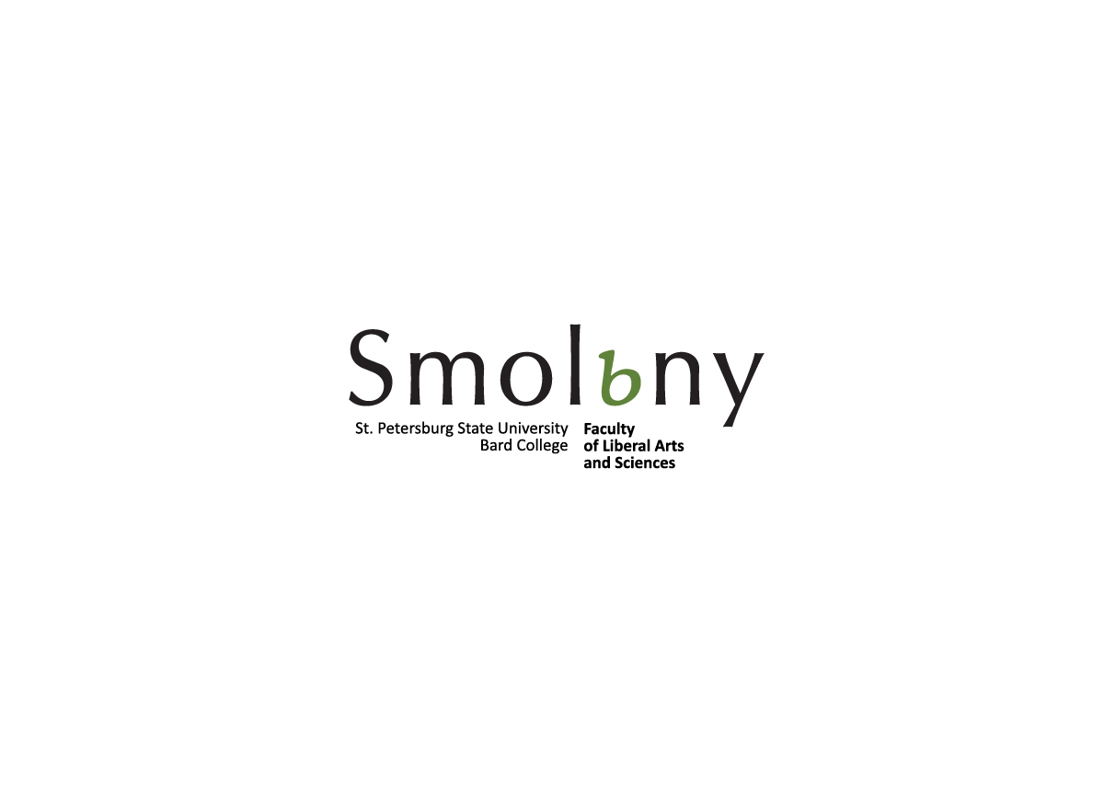In collaboration with St Petersburg State University

and Zurich University of the Arts

St Petersburg, Russia

Only current students of St Petersburg State University and Zurich University of the Arts

are eligible to apply.

22 July - 3 August 2014

**Deadline** for application for participants from **St Petersburg State University**: 23 June 2014

**Deadline** for application for participants from **Zurich University of the Arts**: 16 June 2014

**education@manifesta.org**

**APPLICATION**

|  |  |  |
| --- | --- | --- |
| **Name, Surname** |  | Photo |
| Address |  |
| Tel. |  |
| Email |  |
| Skype Name |  |
| Date of birth |  |
|  |  | |
| Faculty/ Department  (please specify your major studies) |  | |
| Previous Education |  | |
| Do you have any experience in filmmaking or video/sound editing? |  | |
| Why do you want to participate in Manifesta 10 Summer School?  (300 – 500 words) | | |
|  | | |